|  |
| --- |
| How to Enroll Student(s) into CYSH Sections |

1. Go to CYSH via your [Okta Homepage](https://cityyear.okta.com/app/UserHome) (cityyear.okta.com)
2. Find **Sections** on the blue ribbon and then click

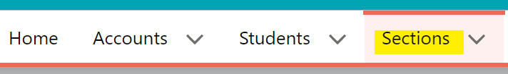

1. Select your preferred view and locate the section

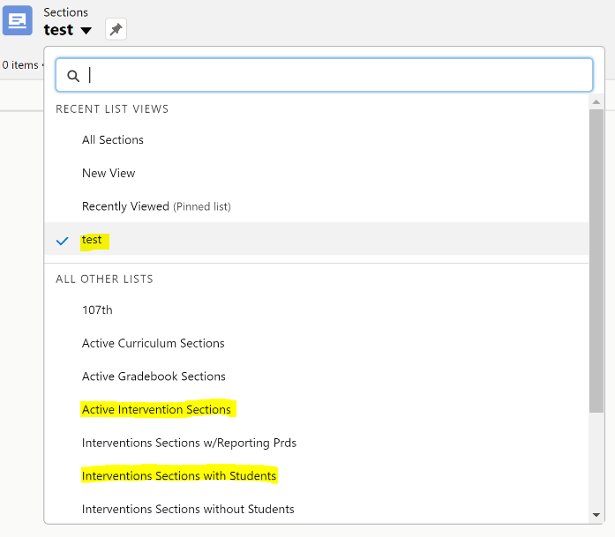

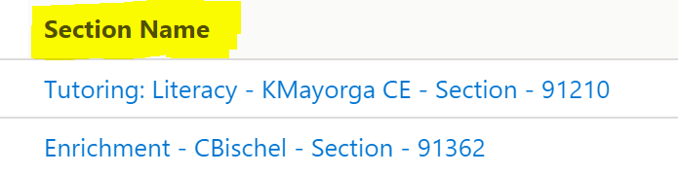

1. Click on Intervention Data on the top-right hand corner



1. Click on Enroll Student(s)

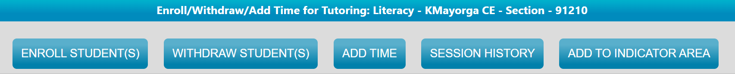

1. Select the date the student first started receiving services

**Note:** If typing in the date, please include a time otherwise the system will not add the student(s) Ex. 8/20/2021 vs 8/20/2021 10:21 AM

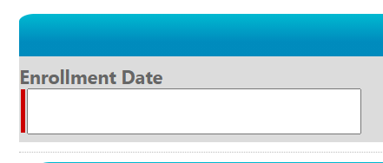

1. Select the students you wish to add to the section by clicking on their name and clicking on the right arrow to move them to the adjacent table.

**Tip:** Use the grade and letter filters to filter the student list down to the grade level they are in and to the first letter of their name

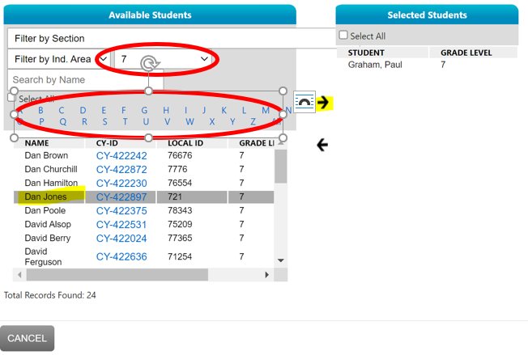

1. Click Save